2-1-1 is a simple, free way to connect people in need with vital human services. By dialing 2-1-1 anywhere in the state of Wisconsin, people are linked to information and referral specialists who provide information about local resources, for everyday life or times of crisis. 2-1-1 provides information from both government and nonprofit organizations. From the single parent seeking food for their children, to the senior citizen looking for in-home care, 2-1-1 brings people and community resources together.

2-1-1 is a statewide, multilingual resource that is available to everyone. It can serve as a resource not only for residents, but also for health care professionals assisting patients with finding the support and services they need.

In Wisconsin, 2-1-1 services can be easily accessed by simply dialing “2-1-1.” It works easily with landlines and cell phone systems across the state. Occasionally there are issues with office-based calls. In some cases, you may need to dial an additional number to get an outside line first.

There are seven 2-1-1 contact centers in the state of the Wisconsin. Each regional center is accessible by dialing 2-1-1 or calling toll free (877) 947-2211. You can also text 898-211 or search our online database at 211wisconsin.org. 2-1-1 services are available 24/7, every day of the year.

2-1-1 Regional Call Centers
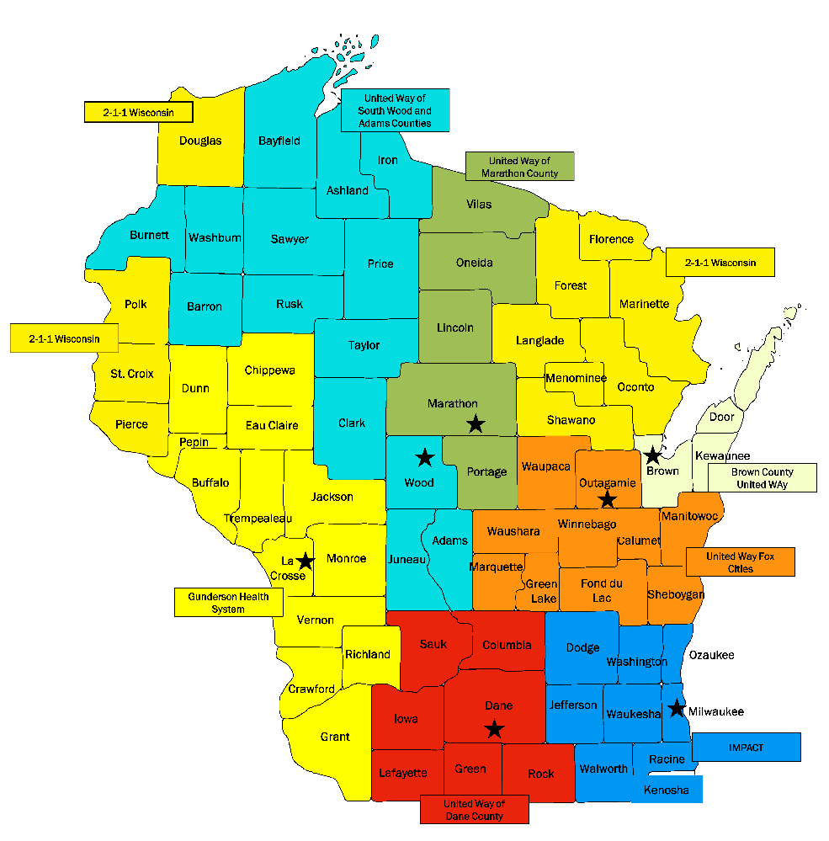
6

The 2-1-1 program provides:
- Information - Regarding a large variety of available services
- Referrals - To specific agencies or organizations in the community
- Advocacy - Some callers struggle with barriers that include language, comprehension issues and anxiety. 2-1-1 information and referral specialists advocate on their behalf to help them access the help they need.
- Crisis intervention - “Crisis” has a broad definition. Examples include a mom who has no formula or diapers for a baby, a family that has no food, mental health emergencies and physical health emergencies.
- Follow-up - As often as possible, 2-1-1 information and referral specialists schedule follow-up calls and/or surveys to ensure people are getting the help they need.
- Statewide interpreter services
- Data collection, analysis, and reporting
- Cooperative program development
- Community outreach
- Emergency preparedness and disaster response
- Access to substance use treatment and recovery services

The Wisconsin Addiction Recovery Helpline
In October 2018, 2-1-1 launched the Wisconsin Addiction Recovery Helpline. The Helpline is a statewide resource for finding substance use treatment and recovery services. The Helpline is free, confidential and available 24/7. This service is funded by a grant from the Wisconsin Department of Health Services. You can reach the Helpline by dialing 2-1-1 or 833-944-4673. You can also visit the helpline’s website at www.addictionhelpwi.org.

Recovery resources include crisis and detoxification services, assessment, counseling, medication-assisted treatment, and both residential and outpatient services. The Helpline also provides follow-up services for callers and helps them remove barriers to getting treatment, such as navigating payment options available through health insurance and finding transportation.

Data Collection
Wisconsin 2-1-1 collects large amounts of data regarding caller demographics, requests received and unmet needs in the communities served. This allows city, county and state governments, United Ways and other organizations to understand what help is needed, who needs the help and what needs are not being met by current efforts. Topics most commonly addressed in calls include housing, food and employment.

What happens during a typical call?
- Active listening and emotional support
- Assessment of needs and the underlying issues
- Problem solving to identify options
- Offering community resources and options that can address the issues
- Assisting with system navigation and providing advocacy when needed
- Offering follow-up for complicated and serious situations
7

Crisis, Emergency Management and Cross Coverage
Although not advertised as a crisis hotline, 2-1-1 receives crisis calls daily. In crisis situations, the information and referral specialists assess for safety and intervene if needed (911, local police). They provide warm transfers to appropriate experts in situations such as mental health emergencies, child abuse/neglect, elder and dependent abuse/neglect, domestic violence, sexual assault and urgent medical concerns. If appropriate, 2-1-1 information and referral specialists will offer to make a follow-up call to check in and offer additional resources or assistance.

2-1-1 Wisconsin uses the same cloud-based telephone technology throughout the state, providing callers with access to specific, locally-based assistance regardless of where they are from or what 2-1-1 center is reached. Wisconsin 2-1-1 centers work together to ensure continuous coverage in the event of a disaster or emergency.

2-1-1 Resource Database
The 2-1-1 program maintains the most complete inventory of family, health and human service providers in Wisconsin. The database includes more than 12,500 agencies, almost 22,000 sites, and nearly 41,000 services, all continuously maintained in real time. The 2-1-1 database can also be accessed online by health care providers and others working with individuals or families. The resources in the database are maintained locally and can be found at www.211wisconsin.org. To find resources outside of Wisconsin, visit www.211.org.

Social Determinants of Health
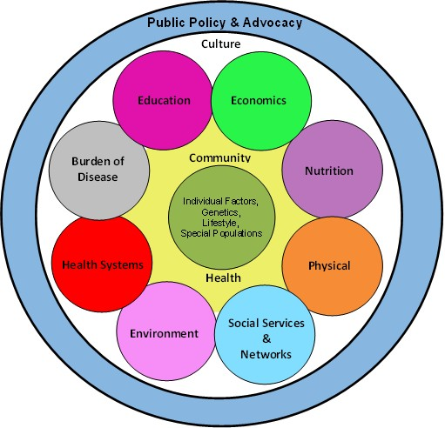
2-1-1’s vast database of health and human services helps individuals, caregivers and professionals connect to community resources that help address the social determinants of health.
8

