The Children and Youth with Special Health Care Needs Program (CYSHCN)
Promoting quality care for children and youth with special health care needs in Wisconsin.

Program Goal

To assure that children and youth with special health care needs are:
- Identified early
- Receive high-quality, coordinated care
- Receive, with their families, the supports they need

The Children and Youth with Special Health Care Needs Program collaborates with national, state and community-based partners to link children to appropriate services, close service gaps, reduce duplication and develop policies to better serve families.

Who are Children and Youth with Special Health Care Needs?

Children and youth with special health care needs (CYSHCN) are defined by the Department of Health and Human Services, Health Resources and Services Administration, Maternal and Child Health Bureau (MCHB) as:

"...those who have or are at increased risk for a chronic physical, developmental, behavioral, or emotional condition and who also require health and related
services of a type or amount beyond that required by children generally."

The CYSHCN Program works to improve systems of care for anyone from birth through age 21 with a chronic physical, developmental, behavioral or emotional illness or condition. Some examples include ADHD, asthma, autism spectrum disorders, childhood cancers, cerebral palsy, deaf or blind, diabetes, Down syndrome, heart disease, and mental health conditions.

Prevalence of CYSHCN

Approximately 13.8 million children ages 0–17 years in the United States (18.8%) have special health care needs. In Wisconsin, approximately 229,000 Wisconsin children have special health care needs (17.8 %).

Source: 2016-2017 National Survey of Children’s Health (NSCH) data query. Data Resource Center for Child and Adolescent Health supported by Cooperative Agreement U59MC27866 from the U.S. Department of Health and Human Services, Health Resources and Services Administration’s Maternal and Child Health Bureau (HRSA MCHB). Retrieved 12/3/18 from www.childhealthdata.org.

14
Wisconsin Regional Centers for CYSHCN

The Wisconsin CYSHCN program supports children, families and providers through five Regional Centers located in Milwaukee, Madison, Neenah, Wausau and Chippewa Falls. Most of their work is done by telephone and directly with families, although in-person meetings also take place. The centers provide support by helping connect families to the complex array of services that they are trying to navigate. These information and referral resources include health care, social support, nutrition (including WIC) and educational services (including Birth to 3 and schools).
15

Health care professionals can refer a child with special health care needs to a Regional Center using a Consent to Release Medical Information Referral form.

The CYSHCN program is measured on these core focus areas:

- Medical Home
- Transition to Adult Care

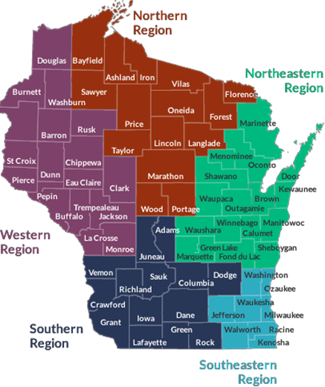

Wisconsin CYSHCN Program Partners

The Well Badger Resource Center provides information and links to services for children, youth, their families and providers. Information is available on services such as Birth to 3 (early intervention), financial assistance, parent networking and support, home health care, therapy services, CYSHCN Regional Centers and more.
800-642-7837
https://wellbadger.org/

Family Voices of Wisconsin supports the voice of families in decision-making, leadership and systems change. Family Voices provides information, training and support around health care and community services for families and professional partners.
608-220-9598
http://www.familyvoicesofwisconsin.com/

Parent to Parent of Wisconsin (P2P) provides parent matching through a statewide network of families who support each other on the journey of parenting children with special health care needs.
888-266-0028
http://p2pwi.org/

The Wisconsin Medical Home Initiative (WisMHI) promotes the early identification of developmental delays and mental health conditions. Additionally, WisMHI works with public health departments, health care teams, communities and families throughout Wisconsin to advance family-centered, integrated care.

www.chawisconsin.org

Health Transition Wisconsin offers resources to assist Wisconsin youth, families and health professionals with the transition from pediatric to adult health care.
https://healthtransitionwi.org/
16
16

