Health Equity is when every person has the opportunity to be as healthy as possible, regardless of race or ethnicity, level of education, gender identity, sexual orientation, income level, the neighborhood they live in, whether or not they have a disability, or other social, economic or environmental factors.

Certain populations, generally those who are socially and economically disadvantaged, bear a disproportionately greater burden of disease and mortality. For example, infant mortality and asthma rates are higher in African American and Hispanic groups than white populations. These differences are what we commonly refer to as health disparities.

The Healthiest Wisconsin 2020 Baseline and Health Disparities Report provides a detailed look into health disparities throughout the state, with data summaries available for racial/ethnic minorities, socio-economic status, people with disabilities, LGBT populations and geography.

Health disparities are created and maintained through complex pathways and often persist despite efforts to reduce or eliminate them by addressing any one cause individually.

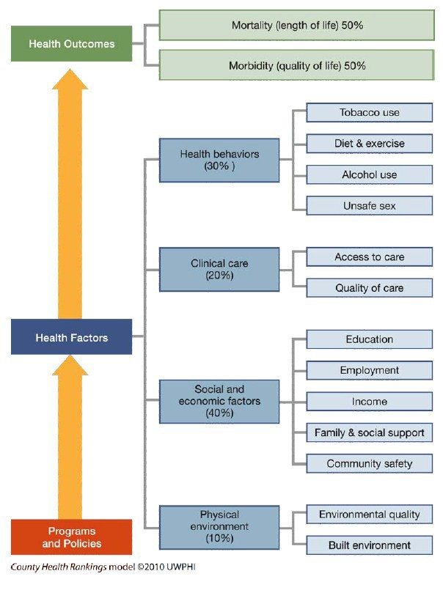
Many factors impact health. The Healthiest Wisconsin 2020 Report classifies these factors as follows:

- Physical factors: housing, transit, air and water quality
- Socioeconomic factors: community safety, family and social supports, income, employment, education

- Clinical care: quality of care, access to care
- Health behaviors: sexual activity, alcohol and drug use, diet and exercise, tobacco use

These physical and socioeconomic factors are referred to as the Social Determinants of Health, the conditions in the environments in which people are born, live, learn, work, play, worship and age. These determinants affect a wide range of health, functioning and quality-of-life outcomes and risks.

Beyond locations or settings, the patterns of social engagement and sense of security and well-being fostered by the conditions in these places impact health, making it important to understand how people experience “place.”
26

Culturally and Linguistically Appropriate Services (CLAS)
Wisconsin residents who come from diverse cultural backgrounds, and for whom English is not their primary language, are at much higher risk for health disparities, in part, because of these cultural and linguistic differences.
Health: The state of complete physical, mental and social well-being.

Health Disparity: A difference in health that is closely linked with social or economic disadvantage.

Health Literacy: The degree to which individuals have the capacity to obtain, process and understand basic health information and services needed to make appropriate health decisions.

The 2013 National CLAS Standards are a comprehensive series of guidelines that inform, guide and facilitate practices related to culturally and linguistically appropriate health services. The CLAS Principal Standard is the overall goal: organizations will provide effective, equitable, understandable, and respectful quality care and services that are responsive to diverse cultural health beliefs and practices, preferred languages, health literacy, and other communication needs.

Implementation of the CLAS standards is increasingly recognized as an effective way to improve quality of services and increase patient safety, effectiveness and patient-centeredness. Below are some resources to help you implement CLAS in your practice.

Additional Resources:
- A Physician’s Practical Guide to Culturally-Competent Care ‒ U.S. Department of Health & Human Services
- CLAS Resources ‒ A compilation of resources and publications related to the provision of culturally and linguistically appropriate services. Allows users to search by type and topic.
- Think Cultural Health
- Unequal Treatment, Confronting Racial and Ethnic Disparities in Healthcare ‒ Institute of Medicine
- Recorded Webinars:
  - Reducing Childhood Disparities: The Intersection between Pediatrics and Public Health
  - Beyond the Right Thing to Do: The Legal Case for CLAS Implementation

Equality ≠ Equity

Equality is when everyone gets the same treatment.
Equity is when everyone gets the treatment they need to achieve
the desired outcome.

* In the context of the Wisconsin Minority Health Program's mission, health disparities are defined as "differences in health outcomes that are adverse and avoidable, which exist between population groups based on gender, age, race, ethnicity, socioeconomic status, geography, sexual orientation, gender identity, disability, special health care needs, or other categories."
27

