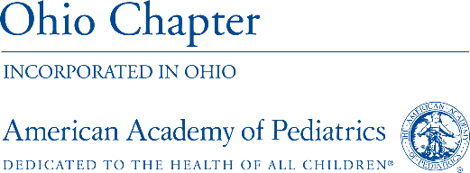

FOR IMMEDIATE RELEASE
April 21, 2020

The Ohio Chapter, American Academy of Pediatrics Encourages Families to Keep Child Wellness Visits and Routine Vaccinations

Columbus, OH – The Ohio Chapter, American Academy of Pediatrics (Ohio AAP) is encouraging families to maintain routine pediatric appointments during the COVID-19 pandemic. In-person, routine well child visits are still recommended for all children at this time, especially children under two who need to maintain their vaccination schedules.

“The risk of missing well care for some children is far greater than the risk of COVID-19 infection” said Kate Krueck, MD, FAAP. “Risks of school failure in grade school children, depression, anxiety and suicidality in adolescents, and asthma exacerbation related to spring allergies and changing weather are all concerns pediatricians can help families address, but we need to see our patients to do so.”

While many non-essential procedures, surgeries and visits were postponed in the early stages of the COVID-19 pandemic, public health officials made it clear that those decisions were made to preserve personal protective equipment for health care professionals, NOT because hospitals or doctor’s offices are unsafe places to visit. Pediatric practices already had protocols in place to keep well visits and sick visits separate, and have further adjusted their operations, putting new policies in place to keep patients and families safe during office visits. Many practices are rooming patients from the car and even seeing ill patients in their cars, and all providers involved in patient care are wearing personal protective equipment and receiving temperature checks daily. Families should call their pediatrician to inquire about what their practice is doing during this time to accommodate well visits, vaccinations and visits for other concerns.

“I want to remind families that, as always, pediatricians all over the state of Ohio are doing everything they can to keep their offices clean, and make sure that when you come to the office, you feel welcome and safe,” said Sarah Adams, MD, Pediatrician. “We are here for Ohio’s children and families, especially during these challenging times.”

In addition to maintaining important wellness checkups and vaccine schedules for children two years old and younger, parents are also encouraged to use telemedicine appointments with their child’s pediatrician to discuss sickness, mental health concerns like anxiety and depression or general questions. Pediatricians can assess during a telemedicine visit if an in-person visit is needed based on each child’s individual situation.

Additionally, Ohio AAP cautions parents about resorting to following unproven and radical advice during this time, such as attending COVID-19 parties to purposefully expose their child to the virus. Instead, parents looking for medically sound advice or tips for talking to Kids about COVID-19, including resources from Ohio AAP, can find them on the Ohio Department of Health website at: https://bit.ly/3eFvtTy

The Ohio AAP promotes the health, safety and well-being of children and adolescents so they may reach their full potential. For more information, visit www.ohioaap.org.
###

MEDIA CONTACT: Jill Buterbaugh, 614-326-9054, jill@krilecommunications.com

